Data Structures Project 2

Şükriye SOYER

150116010

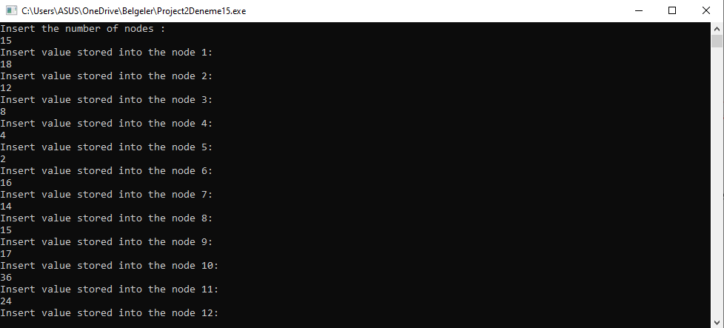

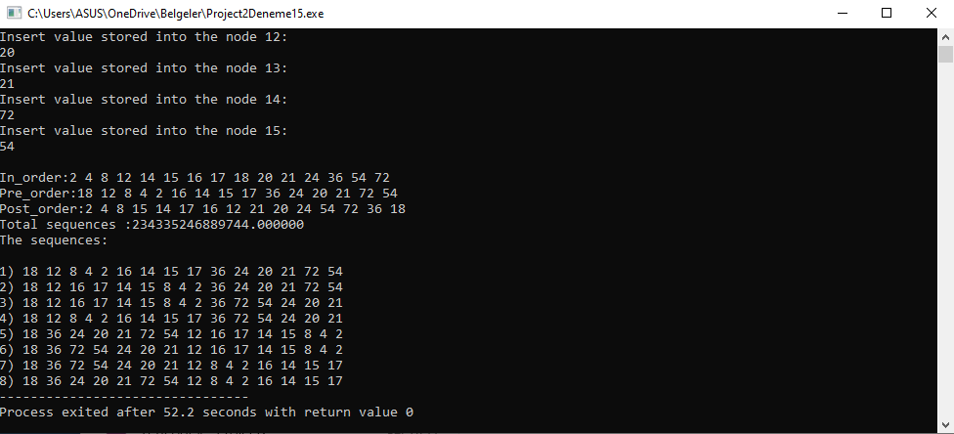

Firstly I created a tree and ı got number of nodes from user and inserted them,to tree using

Node *insert(Node *tree,int x) method.Then with void sort(Node *tree) method ı sorted this numbers inorder; using this method void sort1(Node *tree) to sorted preorder; void sort2(Node *tree) also ı used this method sorted postorder. I did all of them for a and b.Then ı work on c with a lot of methods; finally ı used void mirror(struct Node* tree) method take different sequences have same bts tree also bool convertToMirror(Node *root) method take diferent sequences have same bts tree.I could get some true sequences.Also for c part I find sequences count with using

int binarytree_count_recursive(struct Node *root),double fac (double n),double countt (struct Node *root) methods I try to this formula using recursively (right node number*left node number)*(right node number+left node number)!/(right node number*left node number).

Unfortunately ı didnt find all sequences for part c.